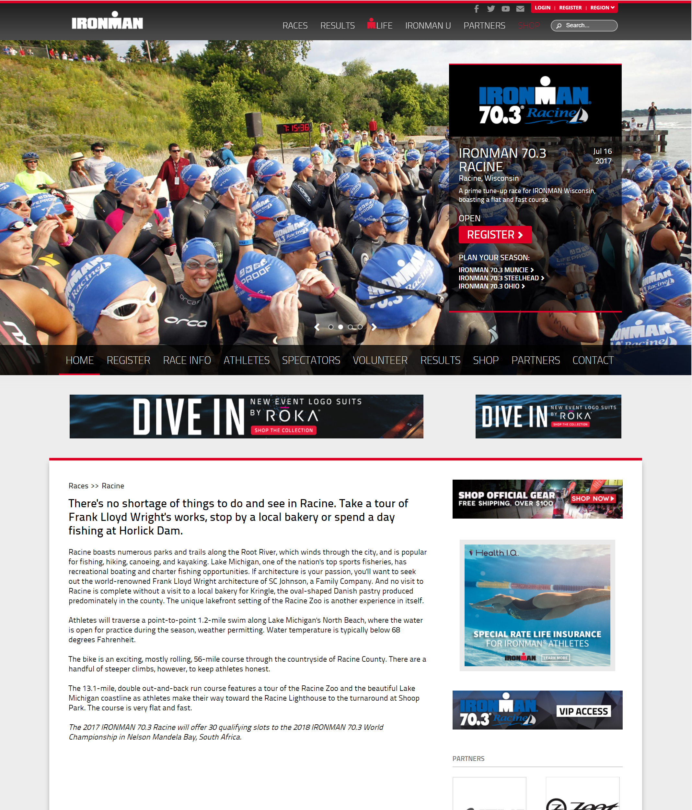

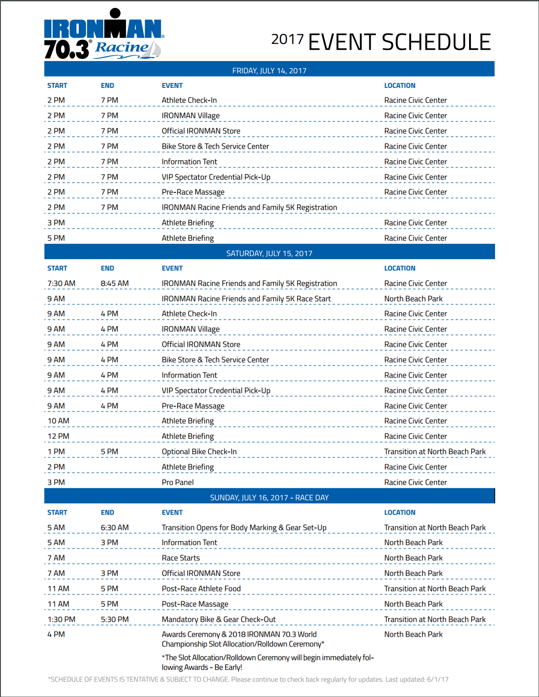

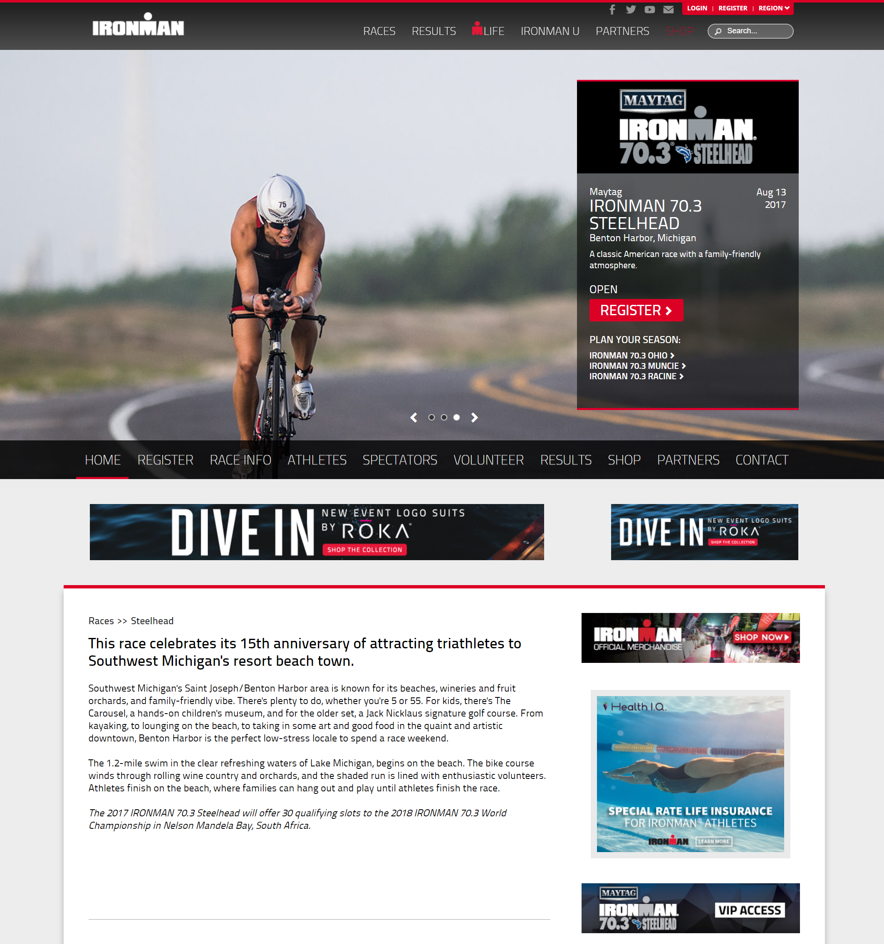

# Maytag IRONMAN 70.3 Steelhead Event Schedule:

The 2017 Maytag IRONMAN 70.3 Steelhead Event Schedule will be posted 8-10 weeks prior to the event.

Link: <http://www.ironman.com/triathlon/events/americas/ironman-70.3/steelhead/race-info/event-schedule.aspx#ixzz4jQL6Hs8D>

Alt Link: <http://www.ironman.com/triathlon/events/americas/ironman-70.3/steelhead/race-info/event-schedule.aspx#axzz4jQ4V1rZ1>

